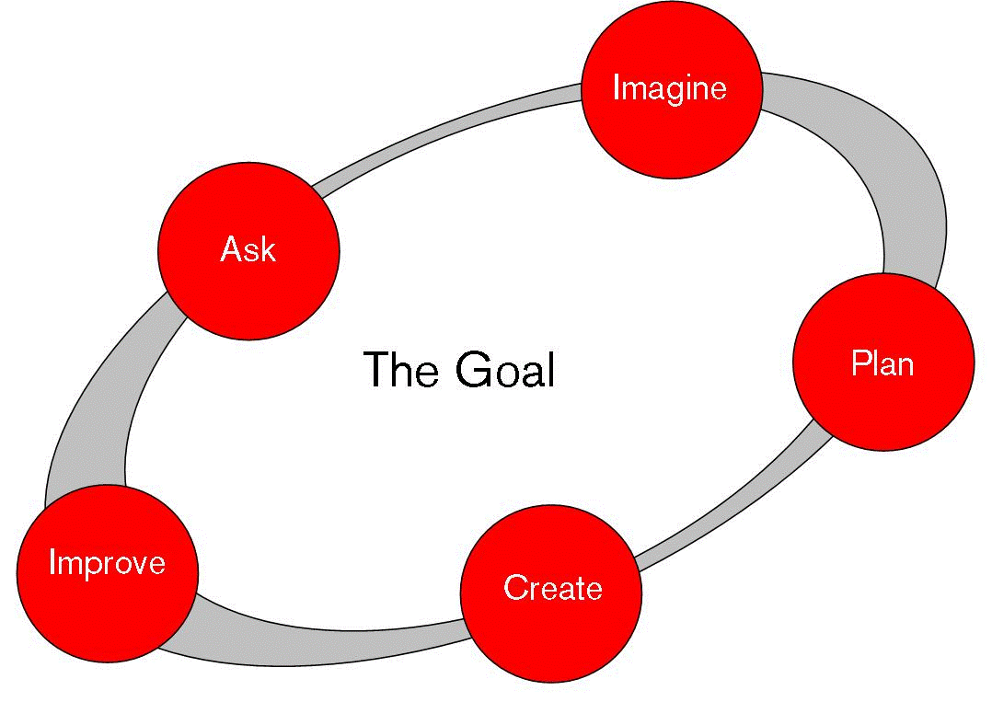
Engineering Design Process

ASK
What is the problem?
What have others done?
What are the constraints?
IMAGINE
What are some solutions?
Brainstorm ideas.
Choose the best one.
PLAN
Draw a diagram.
Make lists of materials you will need.
CREATE
Follow your plan and create it.
Test it out!
IMPROVE
Talk about what works, what doesn't,
and what could work better.
Modify your design to make it better.
Test it out!

